Assignment 21.2

Problem Statement

Implement the below blog at your end and send the complete documentation . https://drive.google.com/file/d/0B_Qjau8wv1KoUThzZ24tT1NsZGs/view?us p=sharing

Question 1 Solution Screen-shot

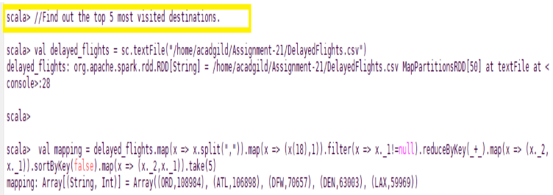

Question 2 Solution Screen-Shot

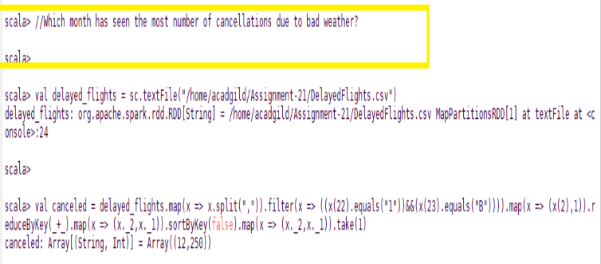

Question 3 Solution Screen-Shot

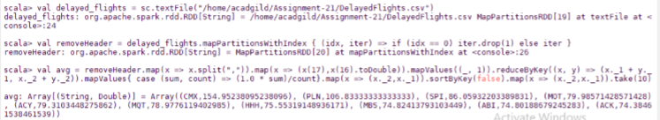

Question 4 Solution Screen-Shot

